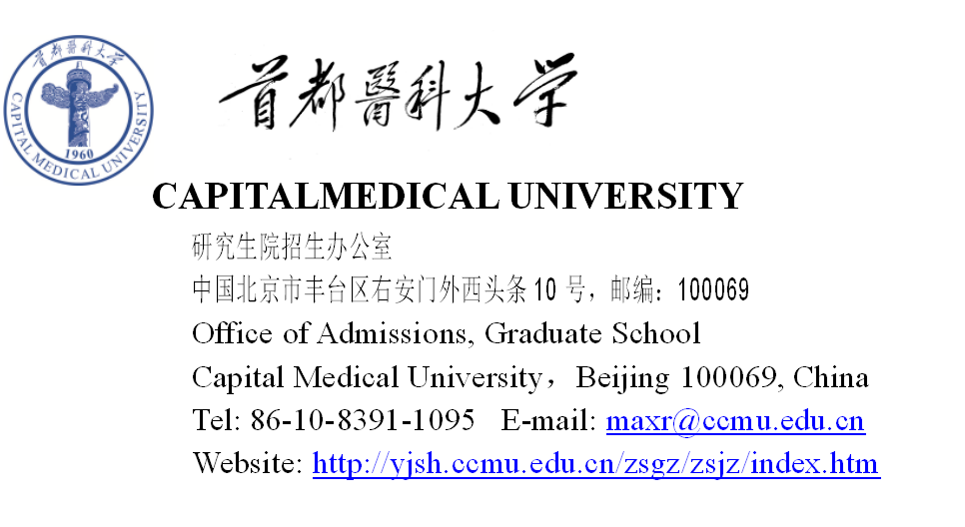

外国留学生入学申请表 (研究生)
Application Form for International Students(Postgraduate Programs)

- 请先阅读本表第四页的填表说明/Please read the notes on the page 4 before filling out the form.
- 请用中文或英文填写此表/Please complete the form in Chinese or English.
- 请用黑色或蓝色签字笔填写此表/Please complete the form in black or blue ink pens.

1．基本情况/Personal Information
护照姓名  Passport Name | 姓/Family name： |  |  |  |  |  | 照  片  Photo
 | 名/Given name：
中文姓名（必填项，不多于6个汉字）
Chinese Name（required, no more than 6 characters）
性别/Gender |  | 国籍/Nationality |  | 婚姻状况/Marital Status
护照号码/Passport No. 有效期至/Valid Until 年/ Yr. 月/ Mon. 日/ Date
出生日期 _________年______月______日  Date of Birth Yr. Mon. Date |  |  |  | 出生地 国家 城市  Place of Birth Country City
最高学位/Highest Degree Obtained： |  |  |  | 学位证书编号/No of Degree:
最高学位毕业学校/ Obtained the Degree from：

毕业时间/time of graduation： 年/ Yr. 月/ Mon.
目前所在机构/Employer or Institution Affiliated： |  |  |  |  |  | 职业/Occupation:
宗教信仰/Religion: |  |  |  | 母语/Native language:
电话/Tel： |  |  | 传真/Fax： |  | Email：
录取通知书邮寄地址/ Address for correspondence
(地址若有变化请及时与研究生院招生办公室联系/Please inform the Office of Admissions, Graduate School for any change of this address)

家庭住址/Home Address

2．教育背景/Educational Background
学校/Institutions | 在校时间/ Time(from-to) | 所获证书/Qualification obtained
特长及爱好/Special skills or interests：

3．工作经历/Employment Experience
工作单位/Employer | 起止日期  Time(from-to) | 从事工作  Work Engaged | 职位  Position

4．语言能力/Language Proficiency
HSK 考试等级/Level of HSK Test：
英语/English： □很好/Excellent □好/Good □较好/Fair □差/Poor
其它语言/ Other Languages：

5．申请项目/ Program Applied for
a .申请类别/Program： □硕士研究生/Master 学位类型/Degree Type: □学术型/Research
□博士研究生/Doctor □专业型/Professional
b. 申请院系/School or Department Applied for：
c. 专业/Major：
d. 研究方向/Research Area：
e. 导师：申请博士生项目须填写/Supervisor:（Only for Doctoral Program）：

6．亲属情况/Family Members
姓名/Name |  | 年龄/Age | 职业/ Occupation | 联系电话/Tel | Email
父亲
Father
母亲
Mother
配偶
Spouse

7．推荐人情况/ Information for Referees
姓名/Name | 工作机构/Organization | 职务/Position | 联系电话/Tel | Email

8．在华事务担保人或机构/ The Guarantor in China
姓名/Name | 联系电话/Telephone
职业/Occupation | Email
工作机构/Employer or Institution Affiliated
联系地址/Address

9．申请人保证/I hereby affirm that
（1）上述各项中所提供的情况是真实无误的/All the information I provided above is true and correct;
（2）在校学习期间遵守中国政府的法规和学校的规章和制度/I shall abide by the laws of the Chinese Government and the regulations of Capital Medical University.

申请人签字/Applicant’s signature____________________日期/Date____________________

10．申请人在递送本申请表的同时，请按简章中的要求提交/ Please send with this form
- 最后学历证明/An official certificate of your highest education (or notarized photocopy)
- 学习成绩单/An official transcripts (or notarized photocopy)
- 个人陈述/ Statement of your research plan
- 推荐信/Two letters of recommendation(original)
- 护照复印件/One photocopy of your passport
- 汉语水平考试（HSK）考试成绩单复印件/Photocopy of HSK scores
- 发表文章及工作成果目录/List of publications and academic achievements
- 申请导师的同意接收函 Consent letter of supervisor
- 申请费 /the application fee
无论申请人是否被录取，上述申请材料恕不退还。
Whether the applicant is accepted or not, all the application materials will not be returned

填表说明
（每一项数字与申请表中每一项序号相对应）
Notes for completion of this application form
(Numbers referring to the various blocks)

- 本项所有内容申请人必须如实填写。
Personal information about the applicant must be filled in truly and correctly.
“照片”：请贴护照尺寸照片。
Please stick a passport-sized photo.
- 请列出已经完成或即将完成的各级教育，从大学填起。Please provide the following information about your education or training background from college.
- 工作经历。Please clarify your work experiences and your current position.
- 申请人的语言情况。Please state your proficiency of languages, especially Chinese.
- 请按研究生招生简章填中的有关信息写报考志愿。Choose your major and department according to Application Information from graduate school of Capital Medical University.
- 申请人亲属的基本情况。General information about the applicant’s family members.
- 推荐人情况。The person or organization that recommends you for application.
- 在华事务担保人或机构，须为在中国境内的人士或机构，以便在紧急时学校能与其取得联系。
The guarantor charging your case, either an individual or an organization, must be in China, so that we can contact them in case of any emergency.
- 申请人保证，须申请人本人签字，没有本人签名，视为申请无效。
The application is invalid without the applicant’s signature.
- 提交的材料请按最新的招生简章的要求提供。
Please provide your application materials according to the up-to-date Application Information.

